Contents
1.0 OVERVIEW AND OBJECTIVE 1
2.0 DESCRIPTION OF MEASURING EQUIPMENT USED 1
3.0 METHOD AND APPROACH DEPLOYED 1
4.0 ATTENDED SITES 2
4.0.1 Forodhani Secondary School
4.0.2 Fish Market
4.0.3 Paje Secondary School
5.0 CONCLUSION AND SUMMARY OF FIGURES OBTAINED 2
6.0 RECOMMENDATION FOR SOLAR POWER DIMENSIONING 2

1.0 OVERVIEW AND OBJECTIVE
In October 2021Sincro and World Mobile installed 5 new Wi Fi hubs at locations in Unguja, Zanzibar as part of the initial stages to provide low cost connectivity to communities in Unguja and Pemba Islands. Whereas for initial trial purposes and expediency the installed sites were connected to mains electricity it is the intention going forward that the majority of sites will be powered by renewable energy, principally solar PV. The purpose of the power logging exercise was to provide reliable and trustworthy data that will form the criteria for dimensioning and selection of the Solar Power requirements per site.

2.0 DESCRIPTION OF MEASURING EQUIPMENT USED
Circutor professional power clamp input logging tool model CIR E3 Auditor serial no.0102405059. measuring range 10-400 V – CAT111,50-60Hz. 9VA

3.0 METHOD AND APPROACH DEPLOYED
It was considered important to obtain power consumption results measured over a 24 hour period in order to gain an accurate picture of total consumption per day and to obtain an indication of peak usage periods. In recognition that different sites may display varying load characteristics the exercise was applied to Fordhani School in Stone Town, Blue Mosque Fish Market in Stone Town and Buccaneer Dive School in Paje. In each case the power logging meter was placed over the incoming mains power cable and results obtained over a 24 hour period. Substantial logs of the raw data obtained over each 24 hour period were analysed, peer reviewed and cross referenced with data obtained from the radio equipment manufacturer’s specification sheets. The graphs shown in this report display peak values registered by the device and do not depict average usage. In the case of Blue Mosque Fish market an examination of the obtained logs revealed anomalous results indicative of interference from nearby equipment and for this reason the exercise was repeated for a 2nd 24 hour period by placing the clamp meter in a position free from the possibility of interference.
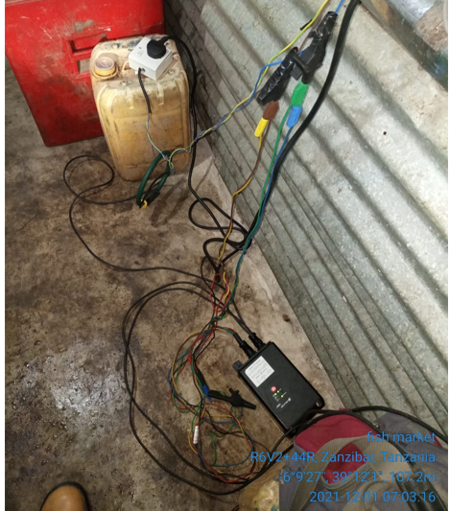

4.0 ATTENDED SITES
Three sites were visited and power consumption details were observed and recovered for 24 hours as seen in the below graphs.
4.0.1 Forodhani Secondary School
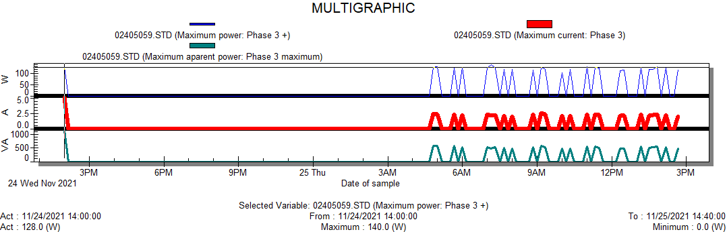
Figure 1: Power trends at Forodhani sec school
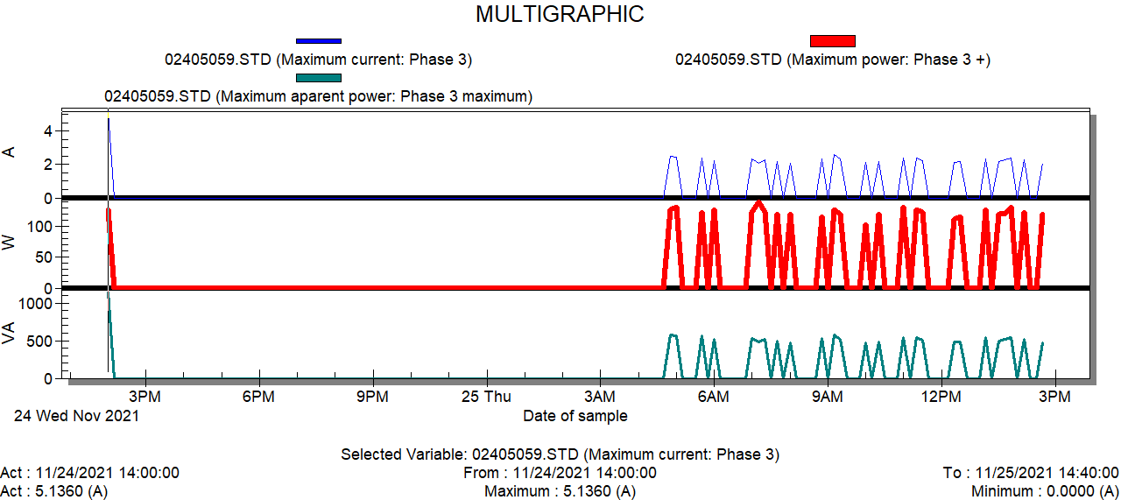
Figure 2: Maximum current at Forodhani sec school

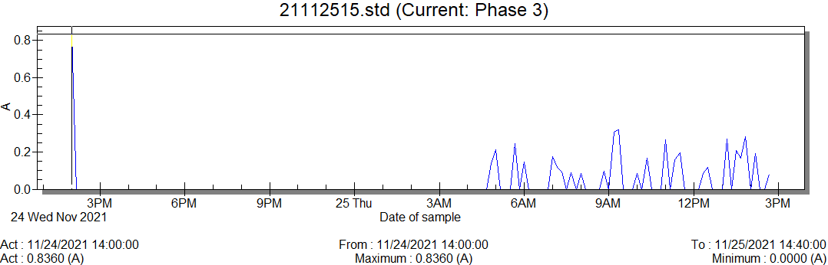
Figure 3: Load current at Forodhani sec school

4.0.2 Fish Market
Below are the logger graphs taken at Fish Market Site
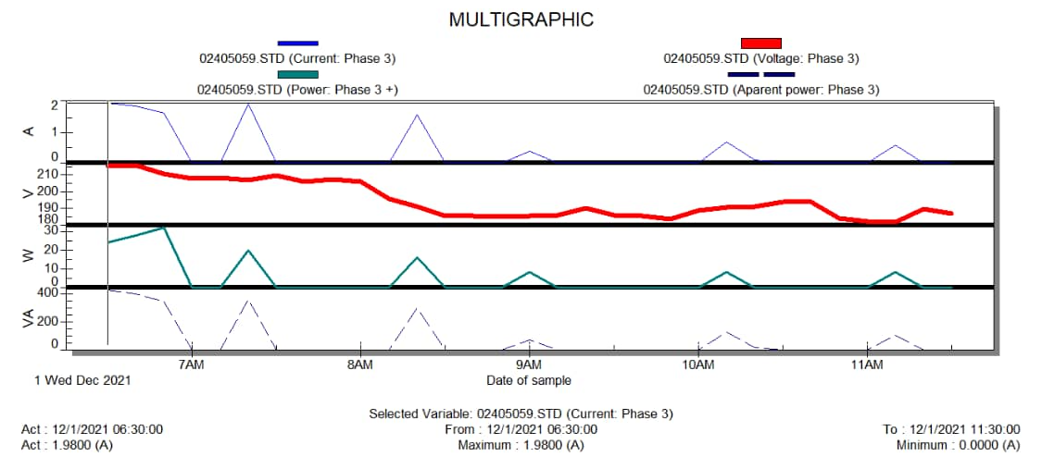Figure 4: Maximum Load current at Fish Market
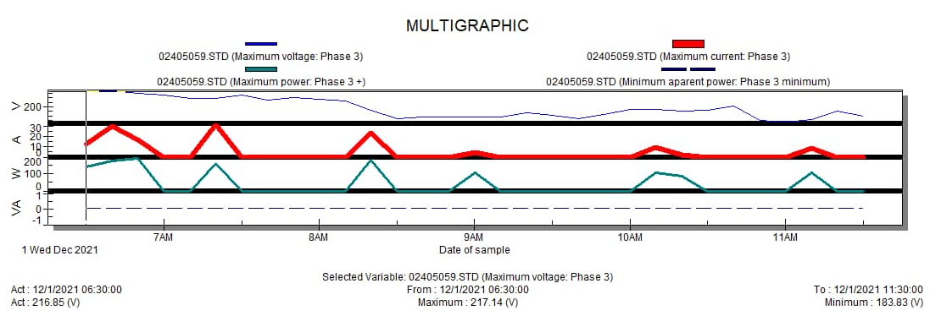
Figure 5: Voltage trending at Fish Market
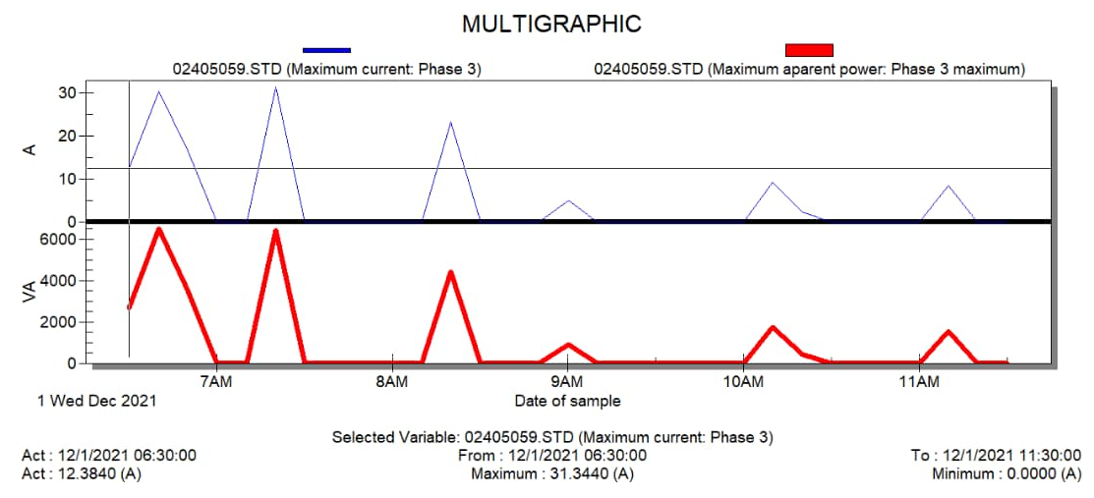
Figure 6: Load current trending at Fish Market

4.0.3 Paje School
Below are recorded data logs for the Paje site
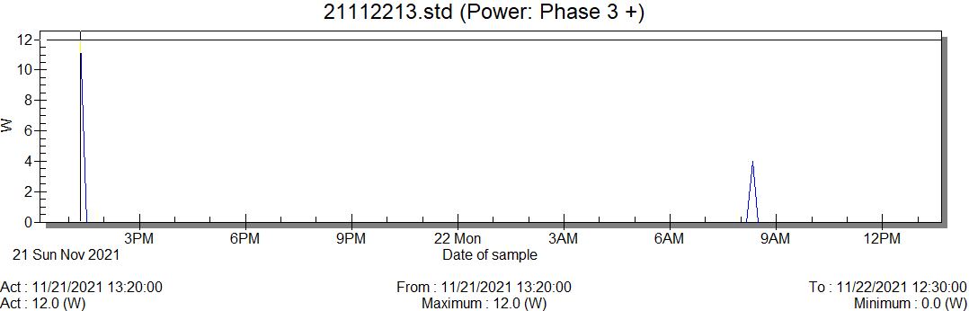
Figure 7: Power at Paje site
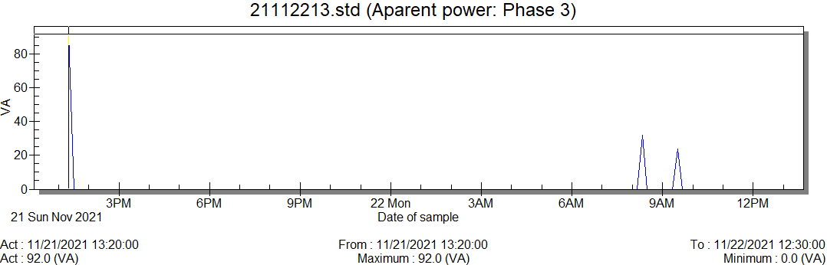
Figure 8: Graph showing maximum Apparent& power trends at Paje site
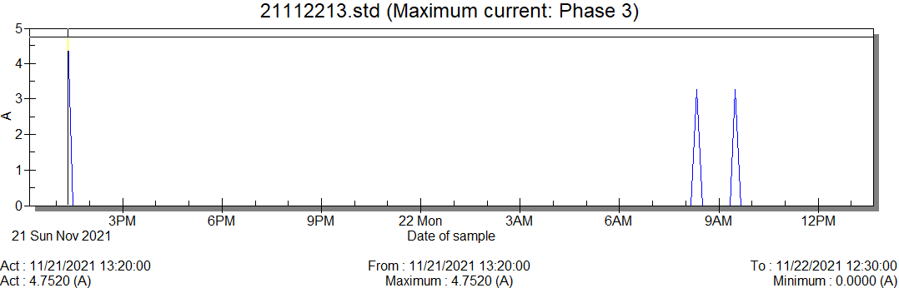
Figure 9: Maximum current at Paje site

5.0 CONCLUSION AND SUMMARY OF FIGURES OBTAINED
Power consumption varied throughout the day with peak average loads being observed between the hours of 7a.m. to 10 p.m. Analysis of the figures obtained indicate a mean peak load of circa 30 amps for sustained periods. Blue Mosque Fish Market being the most active site displayed the highest peak consumption between the hours of 7 a.m. to 2 pm and dropped during the evening period. Instability and fluctuation of incoming mains power was seen on all 3 sites and in the case of Fish Market the grid power was unavailable for 4 hours on the first day of logging. Following peer review of the raw data logs obtained cross referenced with manufacturer’s specification sheets for both the Altai equipment installed on site and comparable equipment from other vendors it is concluded that the power design brief for dimensioning of the solar power consumption for all sites in Zanzibar and Pemba should be based upon a calculated consumption of 70 watts per hour for 15 hours per day, 50 watts per hour for 6 hours per day and 40 watts per hour for 2 hours giving a total daily power requirement of 1,390 watts per day. It should be noted that these figures have taken into consideration power losses from inversion, potential for increased subscribers and improved transmission signal capacity.

6.0 RECOMMENDATION FOR SOLAR POWER DIMENSIONING
A 200 watt PV panel and 60 amp hour48V battery will provide adequate capacity with some potential for repeated outages during periods of occluded solar yield and increased site traffic but this could be mitigated by use of an 80 amp hour 48V battery. It is recognised that the site power should be dimensioned according to the optimum cost benefit equation rather than be over -dimensioned to meet power requirements that may only be required for less than 5% of the time. Given that the increased cost of a 400w panel is only circa 25 dollars a larger panel is recommended however consideration should be given to wind loadings and the engineered strength of the pole. It is considered that application of a 330W panel and 80 amp hour battery is the ‘sweet spot’ for power uptime. This 330W/80Ah installation would have the potential for far fewer outages but it should be noted that during prolonged cloudy periods + 95% power uptime could only be assured by provision of auxiliary rapid charging capacity e.g. a mobile generator travelling from site to site to boost the batteries. In the case of a 330/80Ah configuration and given the known solar yield in Zanzibar this is only likely to be needed for a few days per year.

